Slope Poppers
iPad App: Popplet at http://popplet.com/
Create an account on Popplet and create one project. If you do not create an account, it will not save your progress for you once you exit out of the window.

Directions:
- Create your own real-life problem based on slope and linear equations.
- Include at least one picture in a bubble within the entire project.
- Include at least one diagram within the entire project.
- Explain what you are trying to find.
- Explain what is given to you.
- Include at least one bubble for you to solve something mathematically.
- Finish solving one problem on slope and linear equations. Then have another one next to it that compares your findings.
- Solve again.
- Analyze the differences in the slopes and what that means.
- You are required to used Popplet and at least 2 other websites to help create your Popplet project.
- Take a screenshot of your project with the link to your project once it is completed and submit with a 100-word paragraph that explains what you learned, what websites you used to create your project, and how you feel about this activity. You will turn this in on the website under “iPad Lesson”.

Scoring Guide for Slope Poppers | Points Possible | Points Earned
Chosen problem is related to slope and linear equations | 3
Chosen problem is put into a real-life scenario | 4
Includes at least one photo within entire project | 3
Explains what you are given | 3
Explains what you need to find | 3
Explains how to find what you are solving for | 3
Completely solve both scenarios correctly and clearly | 3
Explain what your slopes represent | 3
Make Popplet easy to understand and interesting to look at | 3
Have a creative title | 3
Analyze and answer the question choosing between the two scenarios | 3
Take a screenshot and send with link of your project on time | 3
Reflection on what you learned, at least 3 websites, and how you felt about the activity | 3
TOTAL POINTS: | 40
Sample Project: Slope Poppers
Created with Poppers on the iPad

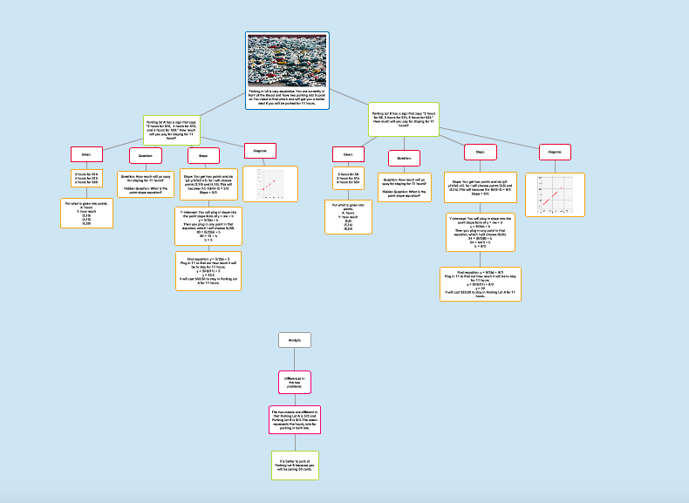

http://popplet.com/app/#/5414626

From this project, I think that it made it more entertaining to learn about slope and how it is something that can be used in the real life. I like how it was something that yes, maybe won’t be actually used in real life if we do encounter this, but it is something that we can use to find the better price from the two parking lots. I also like how I was able to organize the boxes in any way I wanted. For me, I thought that it was easier to create it going vertically down with different colored boxes to represent different things. It allowed me to see the process of what I was doing with not just text, but diagrams and mathematic skills as well. I think that this activity was very technology based, with finding possible situations on the internet to choose from as well as creating my own halfway through and using different applications like Popplet to organize my thoughts and use another website to create the diagram to show the graph. I used Popplet to create this project, found a photo to relate to my problem through google, and create the graph on Simple Plot (http://www.shodor.org/interactivate/activities/SimplePlot/). I think that it brought together technology, English, and Math all into one assignment that it was very fun to do and interesting to see different subjects being combined.

